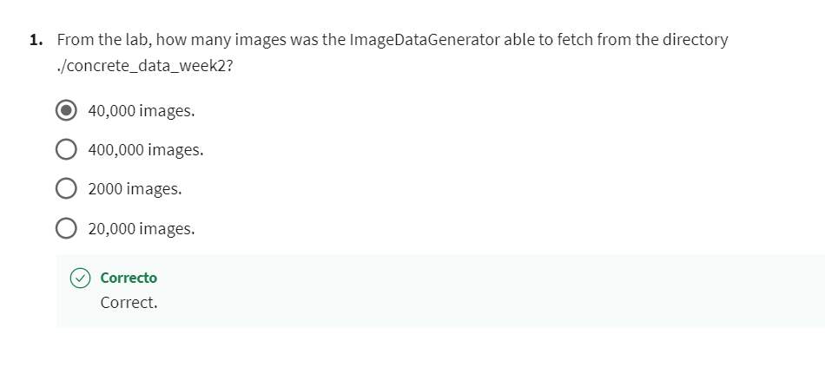

2 Using a random seed of 24 and for a batch size of 4 images, which of the following represent the images in the third batch of the ImageDataGenerator object defined on the entire dataset?

Correct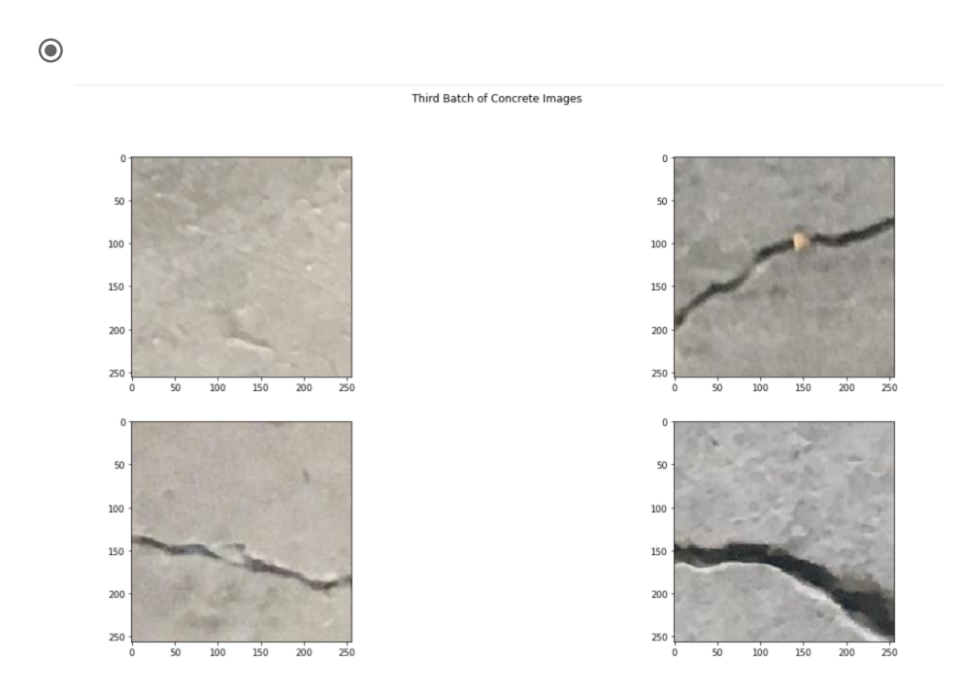

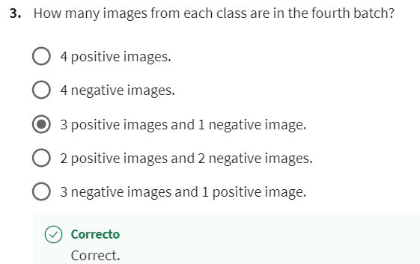

4 Using a random seed of 24 and for a batch size of 4 images, which of the following represents the second image in the fifth batch of the ImageDataGenerator object defined on the entire dataset?

Correct

